http://www.dotnettricks.com/learn/oops/object-oriented-programming-concepts:
Object-Oriented Programming Concepts (www.dotnettricks.com)
Author : Shailendra Chauhan
Posted On : 15 Feb 2011
Updated On : 10 Jul 2012

How to Enable and Disable Client-Side Validation in MVC
MVC3 & MVC4 supports unobtrusive client-side validation. In which validation rules are defined using attributes added to the generated HTML elements. These rules are interpreted by the included JavaScript library and uses the attribute values to configure the jQuery Validation library which does the actual validation work. In this article, I would like to demonstrate various ways for enabling or disabling the client side validation.

Enable Client-Side Validation in MVC
For enabling client side validation, we required to include the jQuery min, validate & unobtrusive scripts in our view or layout page in the following order.
- <script src="@Url.Content("~/Scripts/jquery-1.6.1.min.js")" type="text/javascript"></script>
- <script src="@Url.Content("~/Scripts/jquery.validate.js")" type="text/javascript"></script>
- <script src="@Url.Content("~/Scripts/jquery.validate.unobtrusive.js")" type="text/javascript"></script>
The order of included files as shown above, is fixed since below javascript library depends on top javascript library.

Enabling and Disabling Client-Side Validation at Application Level
We can enable and disable the client-side validation by setting the values of ClientValidationEnabled & UnobtrusiveJavaScriptEnabled keys true or false. This setting will be applied to application level.
- <appSettings>
- <add key="ClientValidationEnabled" value="true"/>
- <add key="UnobtrusiveJavaScriptEnabled" value="true"/>
- </appSettings>
For client-side validation, the values of above both the keys must be true. When we create new project using Visual Studio in MVC3 or MVC4, by default the values of both the keys are set to true.
We can also enable the client-side validation programmatically. For this we need to do code with in the Application_Start() event of the Global.asax, as shown below.
- protected void Application_Start()
- {
- //Enable or Disable Client Side Validation at Application Level
- HtmlHelper.ClientValidationEnabled = true;
- HtmlHelper.UnobtrusiveJavaScriptEnabled = true;
- }

Enabling and Disabling Client-Side Validation for Specific View
We can also enable or disable client-side validation for a specific view. For this we required to enable or disable client side validation inside a Razor code block as shown below. This option will overrides the application level settings for that specific view.
- @model MvcApp.Models.Appointment
- @{
- ViewBag.Title = "Make A Booking";
- HtmlHelper.ClientValidationEnabled = false;
- }
- ...

Custom Validation for Cascading Dropdownlist in MVC Razor
This article will demonstrate, how to make and validate cascading dropdown list with in Asp.Net MVC4 Razor application using custom server-side and client-side validation. In this article, you will learn how set selected value with in Dropdown list in MVC Razor.

How to do it..
Follow the following steps for making and validating cascading dropdown list in mvc razor.

Step 1 : Design Model
- using System;
- using System.Collections.Generic;
- using System.Linq;
- using System.Web;
- using System.ComponentModel.DataAnnotations;
- using System.Web.Mvc;
- using System.Text.RegularExpressions;
- namespace Mvc4_Validate_CascadingDropdown.Models
- {
- public class RegistrationModel
- {
- [Required(ErrorMessage = "Please Enter Email Address")]
- [Display(Name = "UserName (Email Address)")]
- [RegularExpression(".+@.+\\..+", ErrorMessage = "Please Enter Correct Email Address")]
- public string UserName { get; set; }
- [Display(Name = "Country")]
- public Country Country { get; set; }
- [Display(Name = "City")]
- public City City { get; set; }
- [Required(ErrorMessage = "Please Enter Address")]
- [Display(Name = "Address")]
- [StringLength(200)]
- public string Address { get; set; }
- }
- // IClientValidatable for client side Validation
- public class MustBeSelectedAttribute : ValidationAttribute, IClientValidatable
- {
- public override bool IsValid(object value) {
- if (value == null || (int)value == 0)
- return false;
- else return true;
- }
- // Implement IClientValidatable for client side Validation
- public IEnumerable GetClientValidationRules(ModelMetadata metadata, ControllerContext context)
- {
- return new ModelClientValidationRule[]
- {
- new ModelClientValidationRule { ValidationType = "dropdown", ErrorMessage = this.ErrorMessage } };
- }
- }
- public class Country
- {
- [MustBeSelectedAttribute(ErrorMessage = "Please Select Country")]
- public int? ID { get; set; }
- public string Name { get; set; }
- }
- public class City
- {
- [MustBeSelectedAttribute(ErrorMessage = "Please Select City")]
- public int? ID { get; set; }
- public string Name { get; set; }
- public int? Country { get; set; }
- }
- }

Step 2: Design View based on Model
- @model Mvc4_Validate_CascadingDropdown.Models.RegistrationModel
- @{ ViewBag.Title = "Validating Cascading Dropdownlist";
- }
- <script src="../../Scripts/jquery-1.7.1.min.js" type="text/javascript"></script>
- <script src="../../Scripts/jquery.validate.min.js" type="text/javascript"></script>
- <script src="../../Scripts/jquery.validate.unobtrusive.min.js" type="text/javascript"></script>
- <script type="text/jscript">
- //Custom jQuery validation unobtrusive script and adapters
- jQuery.validator.unobtrusive.adapters.add("dropdown", function (options) {
- if (options.element.tagName.toUpperCase() == "SELECT" && options.element.type.toUpperCase() == "SELECT-ONE") {
- options.rules["required"] = true;
- if (options.message) {
- options.messages["required"] = options.message;
- }
- }
- });
- $(function () {
- //get city list on changing of country dropdown list
- $('#Country_ID').change(function () {
- var id = $("#Country_ID :selected").val();
- if (id != "") {
- $.ajax({
- type: "GET",
- contentType: "application/json; charset=utf-8",
- url: '@Url.Action("CityList", "Home")',
- data: { "mCountry": id },
- dataType: "json",
- beforeSend: function () {
- //alert(id);
- },
- success: function (data) {
- var items = "";
- $.each(data, function (i, city) {
- items += "<option value='" + city.Value + "'>" + city.Text + "</option>";
- });
- // Fill City Dropdown list
- $('#City_ID').html(items);
- },
- error: function (result) {
- alert('Service call failed: ' + result.status + ' Type :' + result.statusText);
- }
- });
- }
- else {
- var items = '<option value="">Select</option>';
- $('#City_ID').html(items);
- }
- });
- });
- </script>
- <h2>Custom Validation for Cascading Dropdown List</h2>
- @using (Html.BeginForm())
- {
- <fieldset> <legend>Custom Validation for Cascading Dropdown List</legend>
- <ol> <li>
- @Html.LabelFor(m => m.UserName)
- @Html.TextBoxFor(m => m.UserName, new { maxlength = 50 })
- @Html.ValidationMessageFor(m => m.UserName) </li>
- <li>
- @Html.LabelFor(m => m.Country)
- @Html.DropDownListFor(m => m.Country.ID, new SelectList(ViewBag.Country, "ID", "Name", ViewBag.SelCountry), new { style = "width:310px" })
- @Html.ValidationMessageFor(m => m.Country.ID)
- </li>
- <li>
- @Html.LabelFor(m => m.City)
- @Html.DropDownListFor(m => m.City.ID, new SelectList(ViewBag.City, "ID", "Name", ViewBag.SelCity), new { style = "width:310px" })
- @Html.ValidationMessageFor(m => m.City.ID)
- </li>
- <li>
- @Html.LabelFor(m => m.Address)
- @Html.TextAreaFor(m => m.Address, new { maxlength = 200 })
- @Html.ValidationMessageFor(m => m.Address)
- </li>
- </ol>
- <input type="submit" value="Submit" />
- </fieldset>
- }

Design Controller Based on Model & View
- using System;
- using System.Collections.Generic;
- using System.Linq;
- using System.Web;
- using System.Web.Mvc;
- using Mvc4_Validate_CascadingDropdown.Models;
- using System.Text.RegularExpressions;
- namespace Mvc4_Validate_CascadingDropdown.Controllers {
- public class HomeController : Controller {
- #region Private Methods
- void BindCountry() {
- List<Country> lstCountry = new List<Country>
- {
- new Country { ID = null, Name = "Select" },
- new Country { ID = 1, Name = "India" },
- new Country { ID = 2, Name = "USA" } };
- ViewBag.Country = lstCountry;
- }
- //for server side
- void BindCity(int? mCountry) {
- try {
- if (mCountry != 0)
- {
- //below code is only for demo, you can pick city from database
- int index = 1;
- List<City> lstCity = new List<City>{
- new City { Country = 0, ID=null, Name = "Select" },
- new City { Country = 1, ID=index++, Name = "Delhi" },
- new City { Country = 1, ID=index++, Name = "Lucknow" },
- new City { Country = 1, ID=index++, Name = "Noida" },
- new City { Country = 1, ID=index++, Name = "Guragon" },
- new City { Country = 1, ID=index++, Name = "Pune" },
- new City { Country = 2, ID=index++, Name = "New-York" },
- new City { Country = 2, ID=index++, Name = "California" },
- new City { Country = 2, ID=index++, Name = "Washington" },
- new City { Country = 2, ID=index++, Name = "Vermont" }, };
- var city = from c in lstCity
- where c.Country == mCountry || c.Country == 0
- select c;
- ViewBag.City = city;
- }
- else {
- List<City> City = new List<City> {
- new City { ID = null, Name = "Select" } };
- ViewBag.City = City;
- }
- }
- catch (Exception ex) {
- }
- }
- #endregion
- //for client side using jquery
- public JsonResult CityList(int mCountry) {
- try {
- if (mCountry != 0) {
- //below code is only for demo, you can pick city from database
- int index = 1;
- List<City> lstCity = new List<City>{
- new City { Country = 0, ID=null, Name = "Select" },
- new City { Country = 1, ID=index++, Name = "Delhi" },
- new City { Country = 1, ID=index++, Name = "Lucknow" },
- new City { Country = 1, ID=index++, Name = "Noida" },
- new City { Country = 1, ID=index++, Name = "Guragon" },
- new City { Country = 1, ID=index++, Name = "Pune" },
- new City { Country = 2, ID=index++, Name = "New-York" },
- new City { Country = 2, ID=index++, Name = "California" },
- new City { Country = 2, ID=index++, Name = "Washington" },
- new City { Country = 2, ID=index++, Name = "Vermont" }, };
- var city = from c in lstCity
- where c.Country == mCountry || c.Country == 0
- select c;
- return Json(new SelectList(city.ToArray(), "ID", "Name"), JsonRequestBehavior.AllowGet);
- }
- }
- catch (Exception ex) {
- }
- return Json(null);
- }
- public ActionResult Index()
- {
- return View();
- }
- public ActionResult CustomDropdown()
- {
- BindCountry();
- BindCity(0);
- return View();
- }
- [HttpPost]
- public ActionResult CustomDropdown(RegistrationModel mRegister)
- {
- if (ModelState.IsValid)
- {
- return View("Completed");
- }
- else
- {
- ViewBag.SelCountry = mRegister.Country;
- BindCountry();
- ViewBag.SelCity = mRegister.City;
- if (mRegister.Country != null)
- BindCity(mRegister.Country.ID);
- else
- BindCity(null);
- return View();
- }
- }
- }
- }

How it works..
It's time to run the project and let's see the result as shown below :
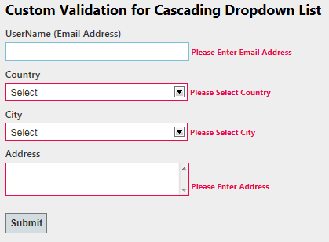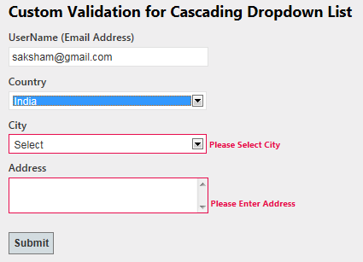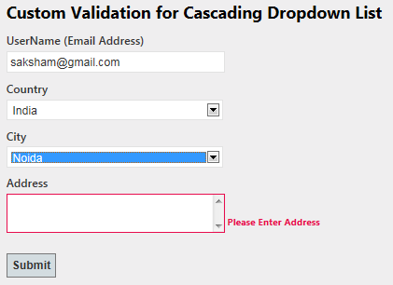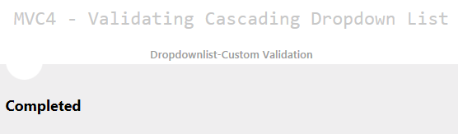

Custom Validation for Checkbox in MVC Razor
This article will demonstrate, how to check whether checkbox is checked or not in Asp.Net MVC4 Razor application using custom server-side and client-side validation.

How to do it..
Follow the following steps for validating checkbox in mvc razor.

Step 1 : Making Custom Attribute
- public class RegistrationModel {
- [Required(ErrorMessage = "Please Enter Email Address")]
- [RegularExpression(".+@.+\\..+", ErrorMessage = "Please Enter Correct Email Address")]
- public string UserName { get; set; }
- [Required(ErrorMessage = "Please Enter Address")]
- [Display(Name = "Address")]
- public string Address { get; set; }
- // Applying Custom Attribute
- [MustBeTrue(ErrorMessage = "Please Accept the Terms & Conditions")]
- public bool TermsAccepted { get; set; } }
- //Making Custom attribute for validating checkbox
- // IClientValidatable for client side Validation
- public class MustBeTrueAttribute : ValidationAttribute, IClientValidatable
- {
- public override bool IsValid(object value)
- {
- return value is bool && (bool)value;
- }
- // Implement IClientValidatable for client side Validation
- public IEnumerable<ModelClientValidationRule> GetClientValidationRules(ModelMetadata metadata, ControllerContext context)
- {
- return new ModelClientValidationRule[] {
- new ModelClientValidationRule { ValidationType = "checkboxtrue", ErrorMessage = this.ErrorMessage } };
- }
- }

Step 2: Making Custom Validation using jQuery
- @model Mvc4_Model_ServerSideValidation.Models.RegistrationModel
- @{
- ViewBag.Title = "Validating CheckBox";
- }
- <script src="../../Scripts/jquery-1.7.1.min.js" type="text/javascript"></script>
- <script src="../../Scripts/jquery.validate.min.js" type="text/javascript"></script>
- <script src="../../Scripts/jquery.validate.unobtrusive.min.js" type="text/javascript"></script>
- <script type="text/jscript">
- //Custom jQuery validation unobtrusive script and adapters
- jQuery.validator.unobtrusive.adapters.add("checkboxtrue", function (options)
- {
- if (options.element.tagName.toUpperCase() == "INPUT" && options.element.type.toUpperCase() == "CHECKBOX")
- {
- options.rules["required"] = true;
- if (options.message) {
- options.messages["required"] = options.message;
- }
- }
- }); </script>
- <h2>Custom Validation for CheckBox </h2>
- @using (Html.BeginForm())
- {
- <fieldset>
- <legend>Custom Validation for Cascading Dropdown List</legend>
- <ol>
- <li>
- @Html.LabelFor(m => m.UserName)
- @Html.TextBoxFor(m => m.UserName, new { maxlength = 50 })
- @Html.ValidationMessageFor(m => m.UserName)
- </li>
- <li>
- @Html.LabelFor(m => m.Address)
- @Html.TextAreaFor(m => m.Address, new { maxlength = 200 })
- @Html.ValidationMessageFor(m => m.Address)
- </li>
- <li>
- @Html.CheckBoxFor(m => m.TermsAccepted)
- @Html.ValidationMessageFor(m => m.TermsAccepted)
- </li>
- </ol>
- <input type="submit" value="Submit" />
- </fieldset>
- }

How it works..
Now, you have applied the custom validation to the checkbox. This validation works for client-side and server side.

ASP.NET MVC Registration form with Validation
Since registration form is a common form, so I prefer it to demonstrate the basic validation in ASP.NET MVC. I have already explained the validation with data annotation and how to enable client side validation in mvc razor, now my focus is to develop registration form with client side and server side validations.

How to do it...

Step1 : Designing Model
First of all we will design the RegistrationModel with data annotation which help us to validate the input data. Since we have no attribute to validate drop down list and checkbox, so I have created custom attributes "MustBeSelected" and "MustBeTrue for validating dropdownlist and checkbox respectively as shown below.
- public class RegistrationModel
- {
- [Required(ErrorMessage = "Please Enter Email Address")]
- [Display(Name = "UserName")]
- [RegularExpression(".+@.+\\..+", ErrorMessage = "Please Enter Correct Email Address")]
- public string UserName { get; set; }

- [Required(ErrorMessage = "Please Enter Password")]
- [StringLength(50, ErrorMessage = "The {0} must be at least {2} characters long.", MinimumLength = 6)]
- [DataType(DataType.Password)]
- [Display(Name = "Password")]
- public string Password { get; set; }

- [Required(ErrorMessage = "Please Enter Confirm Password")]
- [StringLength(50, ErrorMessage = "The {0} must be at least {2} characters long.", MinimumLength = 6)]
- [DataType(DataType.Password)]
- [Display(Name = "Confirm password")]
- [Compare("Password", ErrorMessage = "The password and confirmation password do not match.")]
- public string ConfirmPassword { get; set; }

- [Display(Name = "Country")]
- public Country Country { get; set; }

- [Display(Name = "City")]
- public City City { get; set; }

- [Required(ErrorMessage = "Please Enter Address")]
- [Display(Name = "Address")]
- [StringLength(200)]
- public string Address { get; set; }

- [Required(ErrorMessage = "Please Enter Mobile No")]
- [Display(Name = "Mobile")]
- [StringLength(10, ErrorMessage = "The Mobile must contains 10 characters", MinimumLength = 10)]
- public string MobileNo { get; set; }

- [MustBeTrue(ErrorMessage = "Please Accept the Terms & Conditions")]
- public bool TermsAccepted { get; set; }
- }

- public class MustBeTrueAttribute : ValidationAttribute, IClientValidatable // IClientValidatable for client side Validation
- {
- public override bool IsValid(object value)
- {
- return value is bool && (bool)value;
- }
- // Implement IClientValidatable for client side Validation
- public IEnumerable<ModelClientValidationRule> GetClientValidationRules(ModelMetadata metadata, ControllerContext context)
- {
- return new ModelClientValidationRule[] { new ModelClientValidationRule { ValidationType = "checkbox", ErrorMessage = this.ErrorMessage } };
- }
- }

- public class MustBeSelected : ValidationAttribute, IClientValidatable // IClientValidatable for client side Validation
- {
- public override bool IsValid(object value)
- {
- if (value == null || (int)value == 0)
- return false;
- else
- return true;
- }
- // Implement IClientValidatable for client side Validation
- public IEnumerable<ModelClientValidationRule> GetClientValidationRules(ModelMetadata metadata, ControllerContext context)
- {
- return new ModelClientValidationRule[] { new ModelClientValidationRule { ValidationType = "dropdown", ErrorMessage = this.ErrorMessage } };
- }
- }

- public class Country
- {
- [MustBeSelected(ErrorMessage = "Please Select Country")]
- public int? ID { get; set; }
- public string Name { get; set; }
- }

- public class City
- {
- [MustBeSelected(ErrorMessage = "Please Select City")]
- public int? ID { get; set; }
- public string Name { get; set; }
- public int? Country { get; set; }
- }

- }
As shown above, for creating custom attribute you need to inherit ValidationAttribute class and IClientValidatable interface for Server Side and Client Side Validation.

Step2 : Designing View
Now design the strongly-typed view on the basis of Registration Model. We will also register the client side validation that we have defined in model for the dropdownlist and checkbox by using jquery as shown below.
- @model Mvc4_RegistrationForm.Models.RegistrationModel
- <script type="text/jscript">
- jQuery.validator.unobtrusive.adapters.add("dropdown", function (options) {
- if (options.element.tagName.toUpperCase() == "SELECT" && options.element.type.toUpperCase() == "SELECT-ONE") {
- options.rules["required"] = true;
- if (options.message) {
- options.messages["required"] = options.message;
- }
- }
- });

- jQuery.validator.unobtrusive.adapters.add("checkbox", function (options) {
- if (options.element.tagName.toUpperCase() == "INPUT" && options.element.type.toUpperCase() == "CHECKBOX") {
- options.rules["required"] = true;
- if (options.message) {
- options.messages["required"] = options.message;
- }
- }
- });

- $(function () {
- $('#Country_ID').change(function () {
- var id = $("#Country_ID :selected").val();
- if (id != "") {
- $.ajax({
- type: "GET",
- contentType: "application/json; charset=utf-8",
- url: '@Url.Action("CityList", "Home")',
- data: { "mCountry": id },
- dataType: "json"
- success: function (data) {
- var items = "";
- $.each(data, function (i, city) {
- items += "<option value='" + city.Value + "'>" + city.Text + "</option>";
- });
- $('#City_ID').html(items);
- },
- error: function (result) {
- alert('Service call failed: ' + result.status + ' Type :' + result.statusText);
- }
- });
- }
- else {
- var items = '<option value="">Select</option>';
- $('#City_ID').html(items);
- }
- });

- });

- </script>

- @using (Html.BeginForm())
- {
- lt;fieldset>
- <legend></legend>
- <ol>
- <li>
- @Html.LabelFor(m => m.UserName)
- @Html.TextBoxFor(m => m.UserName, new { maxlength = 50 })
- @Html.ValidationMessageFor(m => m.UserName)
- </li>
- <li>
- @Html.LabelFor(m => m.Password)
- @Html.PasswordFor(m => m.Password, new { maxlength = 50, value = ViewBag.Selpwd })
- @Html.ValidationMessageFor(m => m.Password)
- </li>
- <li>
- @Html.LabelFor(m => m.ConfirmPassword)
- @Html.PasswordFor(m => m.ConfirmPassword, new { maxlength = 50, value = ViewBag.Selconfirmpwd })
- @Html.ValidationMessageFor(m => m.ConfirmPassword)
- </li>
- <li>
- @Html.LabelFor(m => m.Country)
- @Html.DropDownListFor(m => m.Country.ID, new SelectList(ViewBag.Country, "ID", "Name", ViewBag.SelCountry), new { style = "width:310px" })
- @Html.ValidationMessageFor(m => m.Country.ID)
- </li>
- lt;li>
- @Html.LabelFor(m => m.City)
- @Html.DropDownListFor(m => m.City.ID, new SelectList(ViewBag.City, "ID", "Name", ViewBag.SelCity), new { style = "width:310px" })
- @Html.ValidationMessageFor(m => m.City.ID)
- </li>
- <li>
- @Html.LabelFor(m => m.Address)
- @Html.TextAreaFor(m => m.Address, new { maxlength =200 })
- @Html.ValidationMessageFor(m => m.Address)
- </li>
- <li>
- @Html.LabelFor(m => m.MobileNo)
- @Html.TextBoxFor(m => m.MobileNo ,new { maxlength = 10 })
- @Html.ValidationMessageFor(m => m.MobileNo)
- </li>
- <li>
- @Html.CheckBoxFor(m => m.TermsAccepted) I accept the terms & conditions
- @Html.ValidationMessageFor(m => m.TermsAccepted)
- </li>
- </ol>
- <input type="submit" value="Submit" />
- </fieldset>
- }

Step3 : Designing Controller
In the controller defined the methods for binding Country and City dropdown lists. I am not showing the methods here. Also handle the submit button event. We should also check all the validation at server side by checking IsValid property of ModelState.
- public ActionResult RegistrationForm()
- {
- BindCountry();
- BindCity(0);
- return View();
- }

- [HttpPost]
- public ActionResult RegistrationForm(RegistrationModel mRegister)
- {
- //This will check Server Side Validation by using data annotation
- if (ModelState.IsValid)
- {
- return View("Completed");
- }
- else
- {
- // To DO: if client validation failed
- ViewBag.Selpwd = mRegister.Password; //for setting password value
- ViewBag.Selconfirmpwd = mRegister.ConfirmPassword;
- ViewBag.SelCountry = mRegister.Country; // for setting selected country
- BindCountry();
- ViewBag.SelCity = mRegister.City;// for setting selected city

- if (mRegister.Country != null)
- BindCity(mRegister.Country.ID);
- else
- BindCity(null);

- return View();
- }
- }

How it works...
Now run the code and you will find that all the validations are working well as expected.

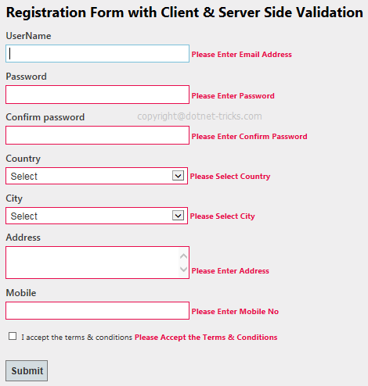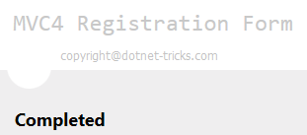

Routing in Asp.Net MVC with example
Basically, Routing is a pattern matching system that monitor the incoming request and figure out what to do with that request. At runtime, Routing engine use the Route table for matching the incoming request's URL pattern against the URL patterns defined in the Route table. You can register one or more URL patterns to the Route table at Application_Start event. MVC5 also supports attribute routing, to know more refer Attribute Routing in ASP.NET MVC.

How to define route...
- public static void RegisterRoutes(RouteCollection routes)
- {
- routes.MapRoute(
- "Default", // Route name
- "{controller}/{action}/{id}", // Route Pattern
- new { controller = "Home", action = "Index", id = UrlParameter.Optional } // Default values for above defined parameters
- );
- }

- protected void Application_Start()
- {
- RegisterRoutes(RouteTable.Routes);
- //To:DO
- }
When the routing engine finds a match in the route table for the incoming request's URL, it forwards the request to the appropriate controller and action. If there is no match in the route table for the incoming request's URL, it returns a 404 HTTP status code.

Note
Always remember route name should be unique across the entire application. Route name can’t be duplicate.

How it works...
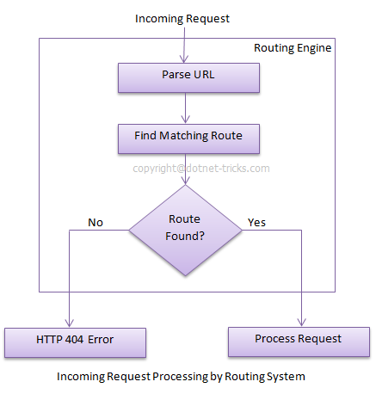
In above example we have defined the Route Pattern {controller}/{action}/{id} and also provide the default values for controller,action and id parameters. Default values means if you will not provide the values for controller or action or id defined in the pattern then these values will be serve by the routing system.
Suppose your webapplication is running on www.example.com then the url pattren for you application will be www.example.com/{controller}/{action}/{id}. Hence you need to provide the controller name followed by action name and id if it is required. If you will not provide any of the value then default values of these parameters will be provided by the routing system. Here is a list of URLs that match and don't match this route pattern.
Matching URLs
Request URL | Parameters
http://example.com/ | controller=Home, action=Index, id=none, Since default value of controller and action are Home and Index respectively.
http://example.com/Admin | controller=Admin, action=Index, id=none, Since default value of action is Index
http://example.com/Admin/Product | controller=Admin, action=Product, id=none
http://example.com/Admin/Product/1 | controller=Admin, action=Product, id=1
http://example.com/Admin/Product/SubAdmin/1 | No Match Found
http://example.com/Admin/Product/SubAdmin/Add/1 | No Match Found

Difference between Routing and URL Rewriting
Many developers compare routing to URL rewriting that is wrong. Since both the approaches are very much different. Moreover, both the approaches can be used to make SEO friendly URLs. Below is the main difference between these two approaches.
- URL rewriting is focused on mapping one URL (new url) to another URL (old url) while routing is focused on mapping a URL to a resource.
- Actually, URL rewriting rewrites your old url to new one while routing never rewrite your old url to new one but it map to the original route.

Route Constraints in Asp.Net MVC with example
In previous article, I have described the Routing and how to create route in your application. Now the time is how to control the behavior of a route. Basically route constraints is way to put some validation around the defined route.

Creating Route Constraints
Suppose we have defined the following route in our application and you want to restrict the incoming request url with numeric id only.Now let's see how to do it with the help of regular expression.
- routes.MapRoute(
- "Default", // Route name
- "{controller}/{action}/{id}", // Route Pattern
- new { controller = "Home", action = "Index", id = UrlParameter.Optional } // Default values for parameters
- );

